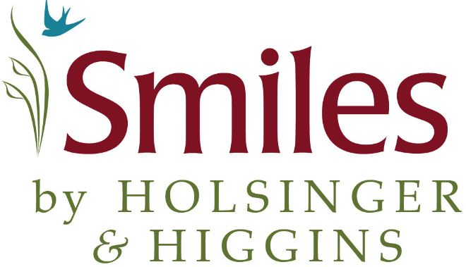

Payment Is Due At Time of Service

- A 10% courtesy for prepayment of dental services at appointment reservation either check, cash, MasterCard, American Express, Visa or Discover
- An 8% courtesy for prepayment of dental services at appointment reservation over the phone.
- A 4% courtesy to Senior citizens for payment in full on day of visit
- A deposit of 50% is required on all appointments. The deposit on a comprehensive exam appointment is non-refundable

*Discounts may NOT be combined with any other discount, special offer or with use of Care Credit services.

*A fee of $45 will be added to your account for all returned checks

I have read and understand the payment options available to me

Signature Date

